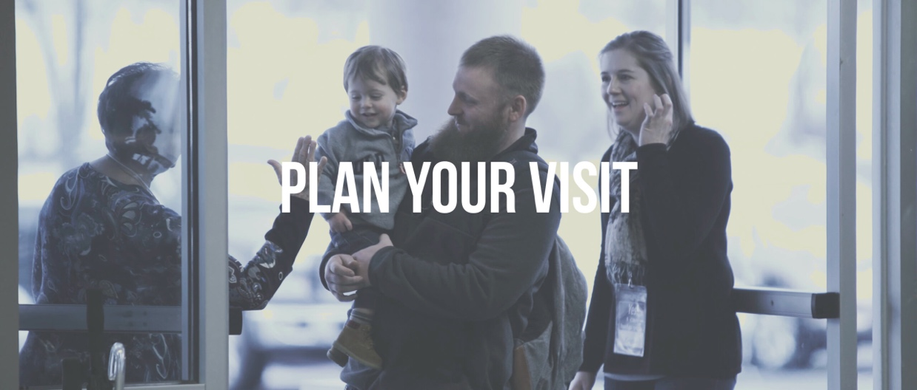

We would love to have you visit us for worship on Sunday. Below is information that we believe will help make your visit amazing. We can’t wait to see you!

What Worship Service Options are there for us?
We have one service at 10:00am in the Family Life Center. This is a contemporary service with a praise band leading worship followed by a message of hope. This service has coffee and breakfast snacks available in the Family Life Center Lobby.

Where do we park when we arrive?
You have lots of parking options when you arrive. There is a County Parking Lot on the North side of our campus (Arcola St and Magnolia). This is the closest parking option. There is also angled parking on the South side of our campus on Myrtle Street.

There is also Guest Parking and Handicap Parking on the East Side of our campus along Arcola Street.

When you arrive, we will have greeters outside waiting to greet you, escort you into the building and show you where things are like the nursery, coffee, donuts, restrooms, and worship spaces. We will help you in any way needed.

What do I wear to worship?
The short answer is whatever you want. Many people dress very casually while some dress kind of business casual. We want you to be comfortable in worship and we will always be happy to welcome you just as you are.

Where do my children go?
We love kids in worship, even if they make noise! We offer Children’s Sunday School at 10:00am for 3rd grade down. We also have teachers that will come down to bring children up to class just before the message starts, that way they can be in worship.

We do offer a nursery for children 4 years of age and younger. Once you arrive, one of our greeters will help show you these areas.

Can I take communion when I come?
Yes! We practice what is called an “open table”. This means that you don’t have to be a member of Bridge Community Church to take communion. The Table of the Lord is open to all people who recognize that they need God’s grace. We will explain communion during the service. You do not have to participate if you prefer not to.

What can we expect when we visit?
If you are interested in “scheduling your visit”, then we will have someone there waiting to meet you personally and they will walk you around and sit with you in service. If you are interested in this type of visit, then email: joe@the-bridge.church and he will let you know who is going to meet you.

When you do arrive, you will find a group of imperfect people who are ready to welcome you as if you were family. We believe that we are better together and that everyone is welcome in God’s house.

We are a laid-back group of people that are committed to building authentic relationships with all people and no one person is more important than the next. We are all God’s children, and all have sacred worth in His eyes.

We are a non-denominational bible-based church that is committed to studying God’s Word. In fact, you will find that a lot of people will have their bibles with them at church so that they can take notes and follow along in worship and class. We encourage people to bring their bibles. No worries, if you don’t have a bible we project scriptures in service. If you would like a bible, we are happy to give you one when you visit.

We also want you to be comfortable, so we will not ask you to stand up or acknowledge that you are a guest in worship. We would love to give you a special gift if you will stop by the welcome center in the lobby of the Family Life Center.

What if I still have questions now or if I have them after our visit?
We would love to answer those questions. You can call us at (979)849-6305 or send an email to: joe@the-bridge.church. We will even schedule a time to meet you for a cup of coffee close to your location. We can’t wait to see you!

